

Local elections in England – What is the message?

2360071 – OLAOYE OYELEKE RIDWAN

**TABLE OF CONTENT**

**Chapter 1 – INTRODUCTION ---------------------------------------------------**

* Background of the study
* Aims of the study
* Questions of interest

**Chapter 2 – DATA & METHODS ---------------------------------------------------**

* Description of the data
* Description of the statistical methods used

**Chapter 3 – STANDARD ANALYSIS ------------------------------------------**

* Exploratory data analysis
* Model fitting and model checking
* Interpretation of analysis
* Conclusions for questions of interest.

**Chapter 4 – ADVANCED ANALYSIS -----------------------------------------**

* Exploratory data analysis
* Model fitting and model checking
* Interpretation of analysis
* Conclusions for questions of interest.

**Chapter 5 – CONCLUSION AND DISCUSSION -------------------------**

* Discussion
* Limitations of study
* Recommendation for further study

CHAPTER 1

# INTRODUCTION

## BACKGROUND OF THE STUDY

The local elections in England was held on 2nd of May, 2019 and the summary of the election result was that the two main parties lost council seats while the minor parties made significant gains. Before to the election, political enthusiasts correctly predicted the direction of change (loss) for the Conservative Party and gain for the Liberal Democrats based on trends observed in the British political-space prior to the election. Our interest is in finding out the characteristics of the local authorities (LAs) where significant change-in-hand happened.

## AIMS OF THE STUDY

Our primary aim in this study is to describe the characteristics of the LAs where significant change-in-hand happened as it relates to the 2016 “Leave EU” referendum, the 2017 general election and distribution of social grades in each local authority (LA).

## QUESTIONS OF INTEREST

Based on the data we have on each LA, for the standard analysis we are interested in describing the characteristics of the LAs;

1. where the Conservative Party lost a large proportion of the seats up for election.
2. where the Labour Party lost a large proportion of the seats up for election.
3. in which the Liberal Democrats, Green and Independents made the largest gains.

For the advanced analysis in this study, we wish to answer the following questions;

1. What is the spatial pattern in the data?
2. Does the data contain spatial autocorrelation or are the units independent?
3. Can we remove the spatial random effect and estimate a spatially smooth mean function for the data?

CHAPTER 2

# DATA AND METHODS

## DESCRIPTION OF THE DATA

For each local authority, we have data on the proportion of people in each social grade (AB, C1, C2, DE). We also have the proportion of votes obtained by each party in the last general election as well as the proportion of leave votes in the 2016 “Leave EU” referendum for each LA.

The United Kingdom Office for National Statistics (ONS) defines a socio-economic classification system based on the occupation of the head of household as follows;

AB - Higher & intermediate managerial, administrative, professional occupations

C1 - Supervisory, clerical & junior managerial, administrative, professional occupations.

C2 - Skilled manual occupations.

DE - Semi-skilled & unskilled manual occupations, unemployed and lowest grade occupations.

The results of the election was obtained from the BBC website a few days after the election. We have data on the seats won by each party in the election, the total number of seats held by each party after the election for each LA and the change in number of seats won by each party as compared with the 2015 local election.

According to BBC, 248 LAs were scheduled to hold elections this year. We consider 207 LAs in this study due to missing observations. We considered two imputation methods, one was replacing the missing cells by the median of the variable and because we have two sets of covariates which have a sum constraint (sum up to 1), the other method involves subtracting the row containing the missing value from 1 and filling the missing cell with the result. The first method was considered inappropriate in that when the missing cell was replaced by the median value, the sum of the row exceeds the row constraint of 1, in the second imputation method considered, the result of subtracting the row values from 1 exceeds the median of the column(variable) by 10 times in some cases. Exploring the datasets obtained from the imputation methods seemed to give a different picture from the original dataset. Out of 207 LAs, seventy three (73) did not put up all seats for election out of which 43 had exactly one-third of their total seats up for election as is customary to some LAs in England.

In a bid to answer the questions of interest and to account for the differences in the number of seats each local authority put up for election, we created a new variable which indicates the proportion change (loss/gain) each party had out of the seats put up for election. This was obtained as follows;

The available seats was obtained by summing the seats each party won in the election for each LA.

In summary, our dataset contains;

Five (5) response variables

* Proportion change for (Conservative, Labour, Liberal Democrats, Independents, Greens) ***– (continuous)***

Eleven (11) explanatory variables

* Proportion of people in social grade (AB, C1, C2, DE) - (***continuous***)
* Vote Share in the 2017 General Election for (Conservative, Labour, Liberal Democrat, UKIP, Green) - (***continuous***)
* Leave EU Vote Share in 2016 referendum - (***continuous***)
* Region of Local Authority (***categorical with 4 levels***)

The “Independents” represents independent candidates, Independent Community and Health Concern Party, Residents' Association of London and Liberal Party. This was done as there was numerous zero counts for the minor parties and no statistically significant result was obtained due to their low representation in the election.

Initially, our categorical variable (Region) had eight (8) levels but while exploring its relationship through a contingency table with our responses, we observed zero counts in some cells which would be inappropriate for our modelling approach. Therefore, we reduced the levels to four (4) by combining as follows;

**Original Levels New Levels**

East East *(East, East Midlands)*

East Midlands North*(North East, North West, Yorkshire and the Humber)*

North East West *(West Midlands)*

North West South *(South East, South West)*

South East

South West

West Midlands

Yorkshire and the Humber

This was done with the aid of the map of England obtained from the Office of National Statistics (ONS) website and making reasonable combinations of the region.

## DESCRIPTION OF STATISTICAL METHODS

Binary logistic regression was used in modelling our dataset. This method was employed due to the specificity of our research questions in that we are interested in identifying the areas where large losses happened for the Conservative and Labour parties and areas where large gains happened for the minor parties. We transformed our continuous variable into binary where our target outcome is large loss (for Conservative and Labour) and large gain(for Liberal Democrats, Greens and Independents) by specifying what large losses meant for the Conservative and Labour parties and what large gains meant for the minor parties respectively. This choice of cut-off was arbitrary and the rationale used in choosing an appropriate cut-off was to make sure there is a fair balance in the two classes (large loss/not a large loss; large gain/not a large gain) as this is necessary for the binary logistic regression to achieve stable results. A loss of more than 15% of the seats up for election in a LA is considered a “large loss” for the Conservative Party; a loss of more than 1% is considered a “large loss” for the Labour Party; a gain of more than 4% is considered a “large gain” for the Independents; a gain of more than 5% is considered a “large gain” for the Liberal Democrats; a gain of more than 1% is considered a “large gain” for the Green Party. In this report we use “change” to imply large loss/not for the Conservative and Labour Party and large gain/not for the Liberal Democrat, Greens and Independents.

For our modelling approach, the dataset was split into five (5), one for each party (Conservative, Labour, Liberal Democrat, Green, Independents) where the response variable in each dataset was the “change” and the continuous covariates are; proportion of social grade (AB, C1, C2, DE), vote share for (Conservative, Labour, Liberal Democrat, UKIP, Green) in the 2017 general election and proportion of “Leave EU” votes in the 2016 referendum. The only categorical variable in each dataset was the region variable with four (4) levels – (North, South, East, West). After examining density plots for the continuous covariates, a univariate logistic regression model was fitted for each covariate to assess their clinical importance using a p-value threshold of 0.25 as recommended by (Scott, Hosmer, & Lemeshow, 2006). The covariates identified to be of clinical importance at this stage are then used for fitting a multivariable logistic regression model to the response variable. Backward stepwise selection method using Akaike Information Criterion (AIC) was implemented to select the final model for each dataset.

### BINARY LOGISTIC REGRESSION

The binary logistic regression method is used to describe the relationship between multiple independent variables and a categorical variable with two outcomes (Ae, 2013). The method does not rely on some of the fundamental assumptions of the linear regression and is able to handle non-linear relationships between dependent and independent variables which is one of the reasons why it was adopted for this study.

To achieve stable results, the binary logistic regression requires the target outcome to be coded as 1, and also careful inclusion of meaningful variables and exclusion of meaningless variables is important. Other assumptions of the logistic regression include little/no multicollinearity, large sample sizes and independence of observations.

### HOSMER-LEMESHOW GOODNESS OF FIT TEST

### RECEIVER OPERATING CHARACTERISTIC CURVE (ROC Curve)

### MORAN’S I TEST FOR AUTOCORRELATION

-----------

CHAPTER 3

# STANDARD ANALYSIS OF THE DATA

## EXPLORATORY DATA ANALYSIS

**Conservative**

**Green**

**Independents**

**Labour**

**Liberal Democrats**

**Proportion Change**

Figure 3.1‑1 Summary of the election result, the boxplot on the far left for the Conservative Party indicates the lowest median value translating to the largest proportion loss compared to the rest parties while the Liberal Democrats had the largest proportion gain on the average indicated by the highest median value.

The Conservative Party lost the largest proportion of seats (-72.2%) in Tunbridge Wells council in the South region, most of the people in this council belong to the social grade AB, in contrast the Conservative Party had the largest vote share for the 2017 general election in this council obtaining 57.5% of the total votes. The leave EU vote share for this council in the 2016 referendum was 45.1%. The party still holds control of the council but the Independents made the largest gain of 33.3% out of the seats that were up for election.

The Labour Party lost the largest proportion of seats (-46.1%) in Sunderland council in the North region, most of the people in this council belong to the social grade DE, similar to the Conservative Party, Labour had the largest vote share in this council in the 2017 general election with 53.3% of the total votes. The leave EU vote share for this council in the 2016 referendum was 61.3%. The party also retains control of the council with the Liberal Democrats and Conservatives having equal proportion gain of 15.3% each.

The Liberal Democrats had their largest proportion gain of 64.2% out of the seats that were up for election in Mole Valley in the South region, most of the people in this region belong to the social grade AB. The Liberal Democrat had a vote share of only 13.5% of the total votes in the 2017 general election and the leave EU vote share for this council was 46.9%. The party gained control of this council from the Conservative Party.

The Independents had their largest proportion gain of 46.1% in Uttlesford council in the East region, the Conservative Party previously held control of this council and also had the largest vote share of 57.1% in the 2017 general election. Majority of the people in this council belong to the social grade AB. The leave EU vote share for this council was 50.6% and the control of the council is currently held by the Resident’s Association of London.

The Green Party made their largest proportion gain of 20.5% in Mid Suffolk council in the East region where majority of the people in the council belong to the social grade C1. The Conservative Party previously held control of this council and had the largest vote share of 54.5% in the 2017 general election. The leave EU vote share for this council was 55.2% and currently, no party has an overall control of the council.

Table 3.1‑1Summary statistics of numerical variables.

|  |  |  |  |  |
| --- | --- | --- | --- | --- |
| **Variable Name** | **Min** | **Mean** | **Median** | **Max** |
| Social Grade AB | 0.1027 | 0.2267 | 0.2130 | 0.4403 |
| Social Grade C1 | 0.2317 | 0.3043 | 0.3039 | 0.3791 |
| Social Grade C2 | 0.1211 | 0.2233 | 0.2286 | 0.3282 |
| Social Grade DE | 0.1072 | 0.2457 | 0.2389 | 0.4088 |
| Proportion of Conservative Vote 2017 | 0.0893 | 0.4532 | 0.4886 | 0.6472 |
| Proportion of Labour Vote 2017 | 0.0696 | 0.2604 | 0.2146 | 0.7414 |
| Proportion of Liberal Democrat Vote 2017 | 0.0170 | 0.0829 | 0.0623 | 0.4257 |
| Proportion of UKIP Vote 2017 | 0.0557 | 0.1540 | 0.1490 | 0.3402 |
| Proportion of Green Vote 2017 | 0.0185 | 0.0409 | 0.0381 | 0.2040 |
| Proportion of Leave Votes in 2016 Referendum | 0.2615 | 0.5630 | 0.5639 | 0.7556 |
| Proportion change for Conservatives | -0.7222 | -0.1574 | -0.1304 | 0.3125 |
| Proportion change for Labour | -0.4615 | -0.0055 | 0 | 0.4545 |
| Proportion change for Liberal Democrats | -0.0976 | 0.0838 | 0.0357 | 0.6429 |
| Proportion change for Green | -0.0625 | 0.0232 | 0 | 0.2059 |
| Proportion change for Independents & Others | -0.0732 | 0.0690 | 0.0313 | 0.4615 |

The statistics shown on Table 3.1.1. shows that on the average, 22.6% are in the AB social grade, 30.4% are in the C1, 22.3% in C2, 24.5% in DE. Social grades across areas shows symmetric distribution as median almost equals mean for each grade classification. The statistics indicate that the Conservative Party had a maximum loss of 72.2% and a maximum gain of 31.2% of the seats that were up for election. Labour had a maximum loss of 46.1% and a maximum gain of 45.4%. The independents (including other minor parties) had a maximum loss of 7% and a maximum gain of 46.1%. UKIP had a maximum loss of 58.9% and a maximum gain of 11.7%. Green Party had a maximum loss of 6% and a maximum gain of 20% and the Liberal Democrats had a maximum loss of 9% and a maximum gain of 64.2%.

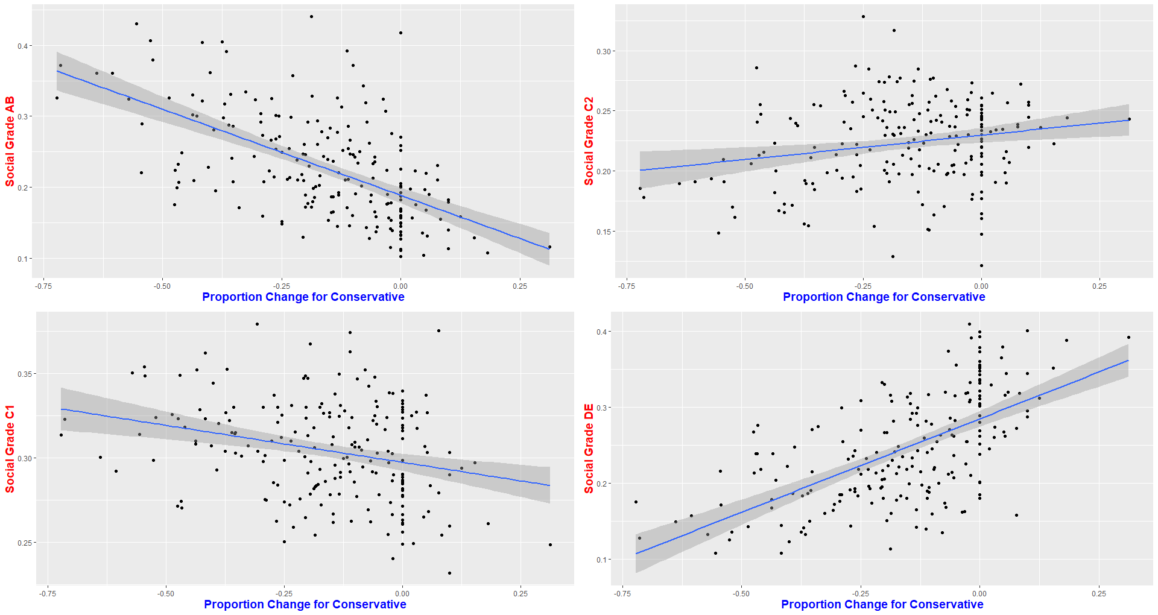

Figure 3.1‑2. Scatterplot indicating a class divide in choice of support for the Conservative Party

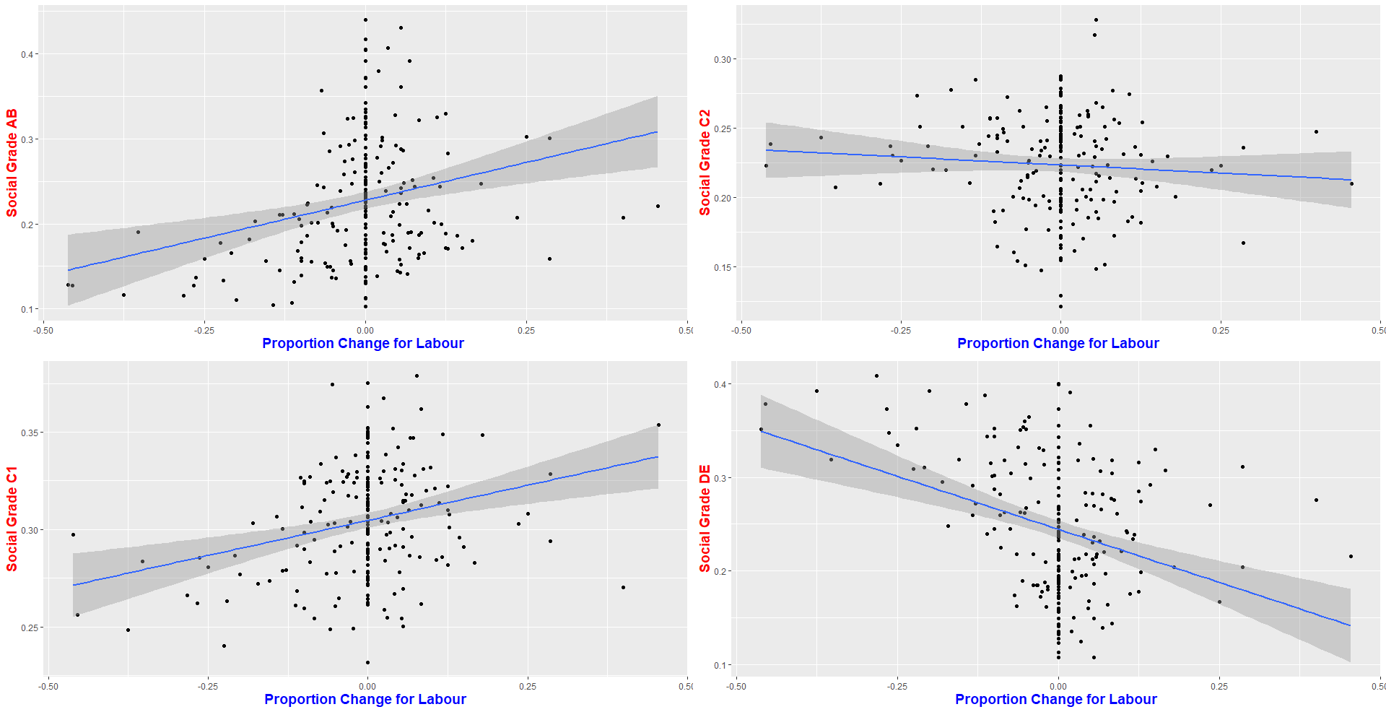

Figure 3.1‑3. Scatterplot indicating a class divide in choice of support for the Labour Party

The scatterplots in Fig 3.1.2 and Fig 3.1.3 indicates a class divide in the choice of support for the two main parties (Conservative and Labour). In Fig 3.1.2, the Conservative Party seem to be favoured more in areas with high proportion of people in social grades C2 and DE, this is the opposite for the Labour Party as evidenced in Fig 3.1.3. This trend was also reported in (Jennings & Stoker, 2017) as a political divide between residents of areas connected to global growth and those who are not.

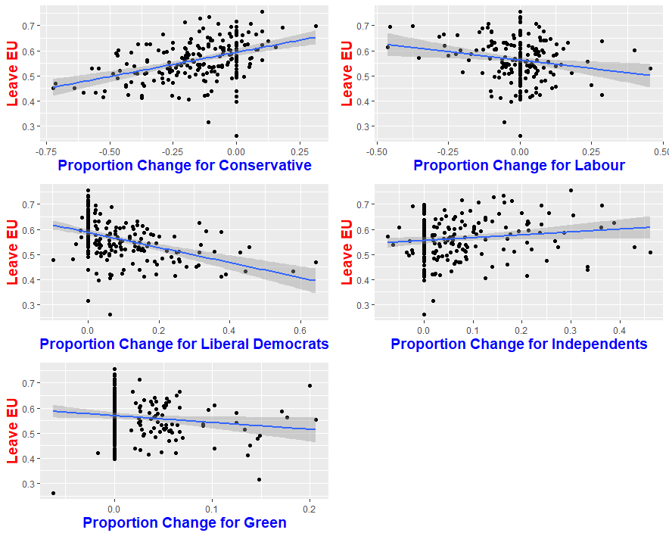

Figure 3.1‑4. Influence of “Leave EU” on voting pattern.

The scatterplots presented in Fig 3.1.4. evidences the pattern of relationship between the Leave EU vote share and proportion change for each political party. A clear trend is observed for the Conservative Party as their only gains seemed to have come from areas that had more than 50% proportion of Leave EU votes, the pattern is not quite clear for the other parties. The Liberal Democrats, Independents and Green Party seemed to have made gains from everywhere.

Table 3.1‑2. A univariate analysis of the Conservative “change” using a p-value threshold of 0.25 to select variables of clinical importance as recommended by (Scott et al., 2006).

|  |  |
| --- | --- |
| **Variable Name** | **P-Value** |
| Social Grade AB | <0.25 |
| Social Grade C1 | <0.25 |
| Social Grade C2 | 0.387 |
| Social Grade DE | <0.25 |
| Conservative Vote Share 2017 | <0.25 |
| Labour Vote Share 2017 | <0.25 |
| LibDem Vote Share 2017 | <0.25 |
| Green Vote Share 2017 | <0.25 |
| UKIP Vote Share 2017 | <0.25 |
| Leave EU Votes | <0.25 |

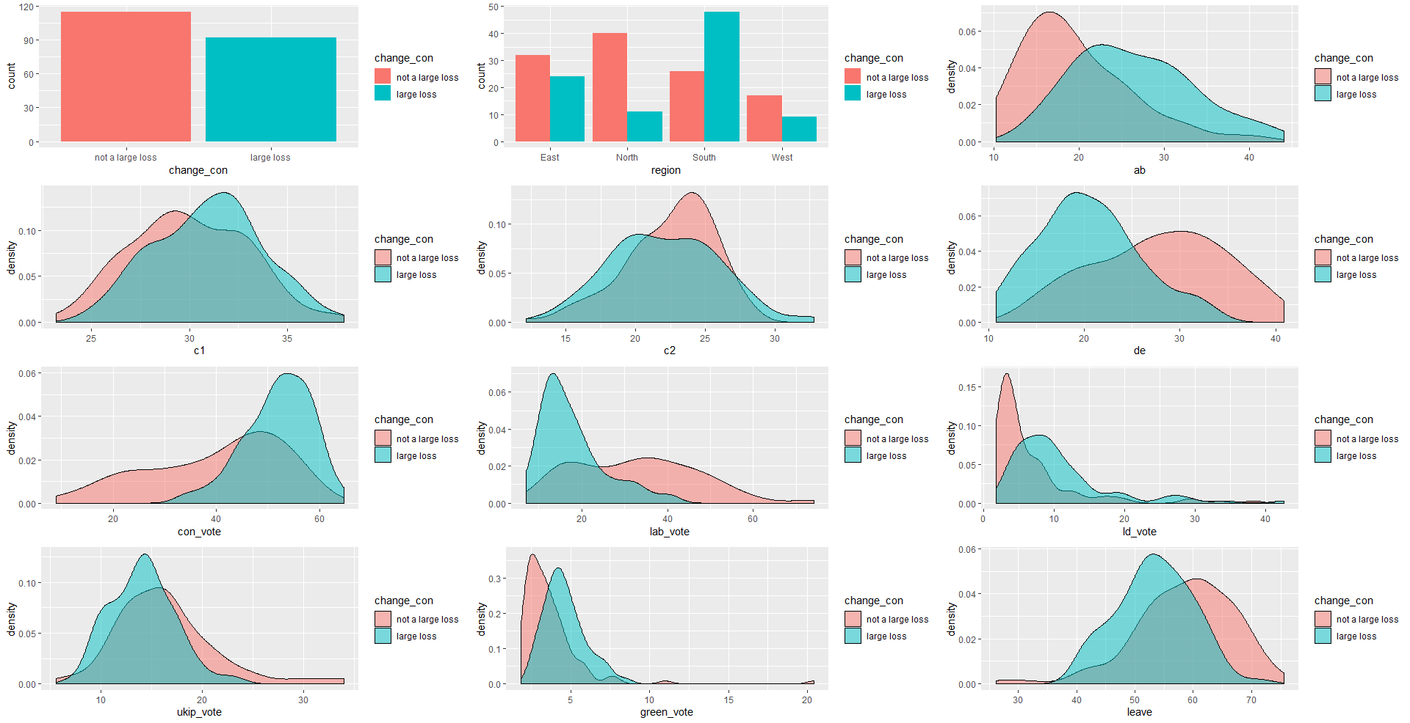

Figure 3.1‑5. Barplots and Density plots for the Conservative dataframe.

The results of the univariate analysis presented in Table 3.1.2 suggests that “Social Grade C2” is not of clinical importance in predicting whether or not the Conservative party will lose a large proportion of seats in a local authority. This is also evidenced in Fig 3.1.5 (e) as there is an overlap in the distribution of the two classes (large loss/not a large loss). Ideally, a separation of distribution suggests the variable to be associated with the target outcome. The barplot in Fig 3.1.5 (a) was used to assess the balance in the two classes (large loss/not a large loss) while the barplot in Fig 3.1.5(b) was used to make sure there are no zero values in each level of our categorical variable (region), the barplot also suggests that most of the large loss for the Conservative party came from the South.

Table 3.1‑3. A univariate analysis of the Labour “change” using a p-value threshold of 0.25 to select variables of clinical importance as recommended by (Scott et al., 2006)

|  |  |
| --- | --- |
| **Variable Name** | **P-Value** |
| Social Grade AB | <0.25 |
| Social Grade C1 | <0.25 |
| Social Grade C2 | 0.994 |
| Social Grade DE | <0.25 |
| Conservative Vote Share 2017 | <0.25 |
| Labour Vote Share 2017 | <0.25 |
| LibDem Vote Share 2017 | <0.25 |
| Green Vote Share 2017 | 0.475 |
| UKIP Vote Share 2017 | 0.850 |
| Leave EU Votes | <0.25 |

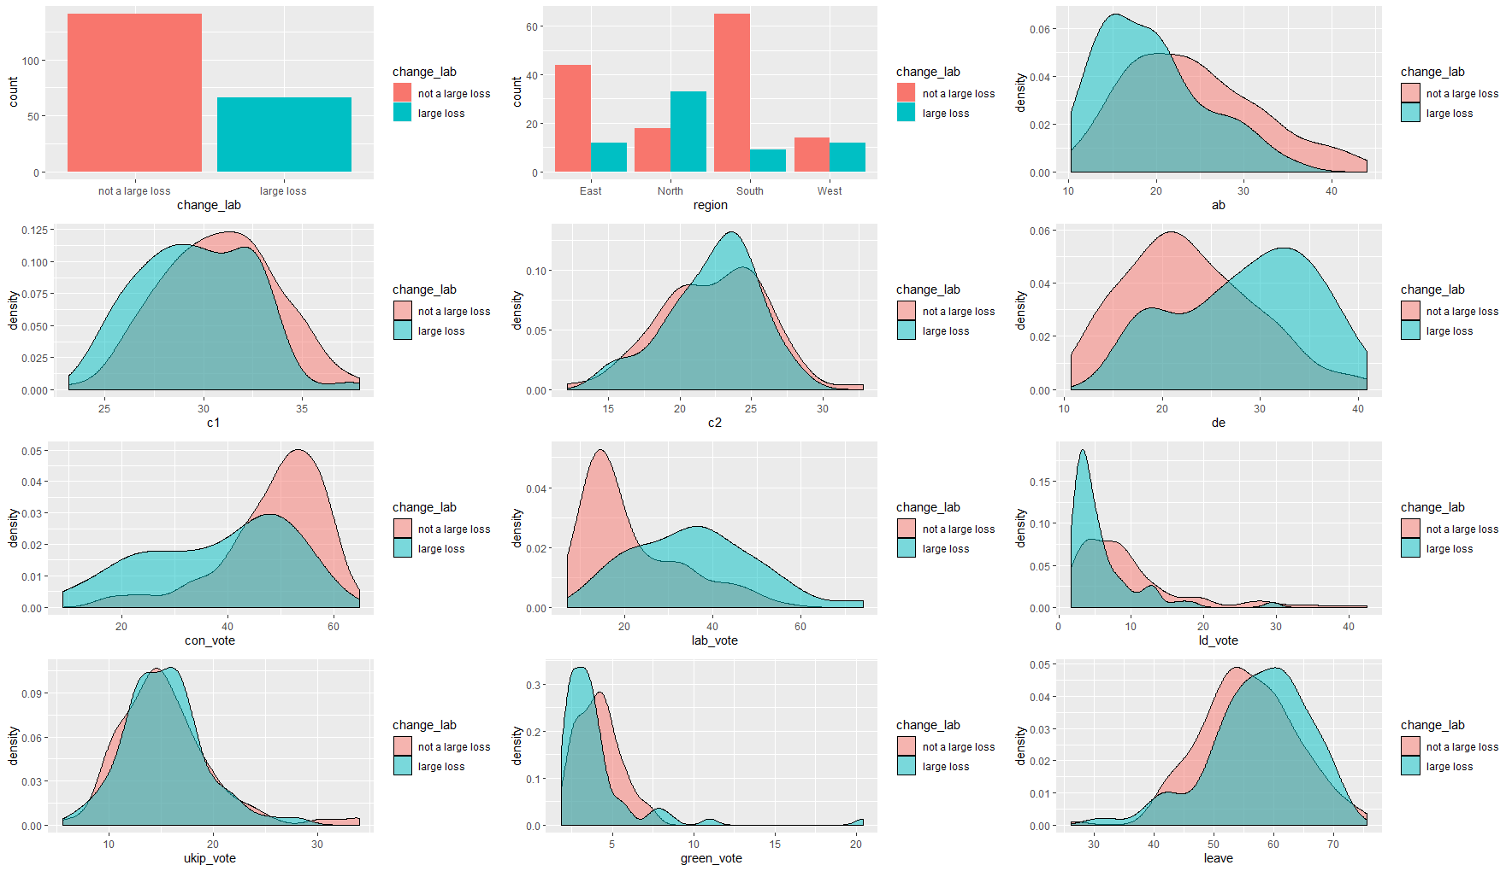

Figure 3.1‑6. Barplots and Density plots for the Labour dataframe

The results of the univariate analysis presented in Table 3.1.3 suggests that Social Grade C2, Green Vote Share 2017 and UKIP Vote Share 2017 are not of clinical importance in predicting whether or not the Labour party will lose a large proportion of seat. An overlapping distribution of the two outcomes is obvious in Fig 3.1.6. (e and j). As evidenced in Fig 3.1.6 (a), we could not obtain a cut-off that yields a fair balance in the two classes for the Labour party as they only had 66 losses in 207 LAs, this poses a limitation for our modelling approach. The barplot in Fig 3.1.6 (b) suggests that their largest losses came from the North.

Table 3.1‑4. A univariate analysis of the Liberal Democrat “change” using a p-value threshold of 0.25 to select variables of clinical importance as recommended by (Scott et al., 2006).

|  |  |
| --- | --- |
| **Variable Name** | **P-Value** |
| Social Grade AB | <0.25 |
| Social Grade C1 | <0.25 |
| Social Grade C2 | <0.25 |
| Social Grade DE | <0.25 |
| Conservative Vote Share 2017 | <0.25 |
| Labour Vote Share 2017 | <0.25 |
| LibDem Vote Share 2017 | <0.25 |
| Green Vote Share 2017 | <0.25 |
| UKIP Vote Share 2017 | <0.25 |
| Leave EU Votes | <0.25 |

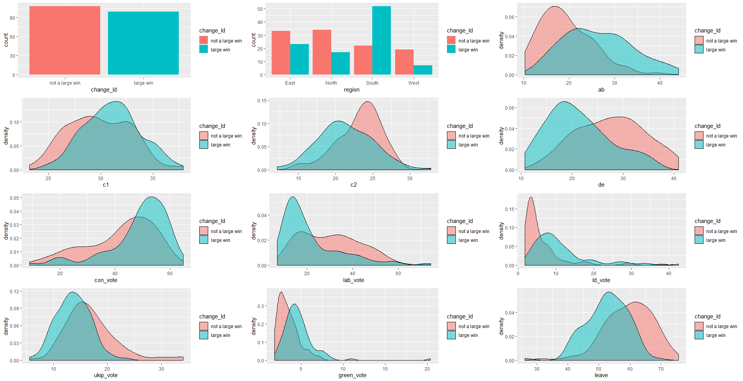

Figure 3.1‑7. Barplots and Density plots for the Liberal Democrat dataframe.

The results of the univariate analysis presented in Table 3.1.4 suggests that all the continous covariates are relevant in predicting whether or not the Liberal Democrats will make a large proportion gain in local authority. This is also evidenced in the density plots shown in Fig 3.1.7 (c-l) as there is no complete overlap in the plots. We were able to achieve a balance in the two classes as shown in Fig 3.1.6 (a). The barplot in Fig 3.1.6 (b) suggests that most of their large gains came from the south.

Table 3.1‑5. A univariate analysis of the Independents “change” using a p-value threshold of 0.25 to select variables of clinical importance as recommended by (Scott et al., 2006)

|  |  |
| --- | --- |
| **Variable Name** | **P-Value** |
| Social Grade AB | 0.867 |
| Social Grade C1 | 0.379 |
| Social Grade C2 | <0.25 |
| Social Grade DE | 0.492 |
| Conservative Vote Share 2017 | <0.25 |
| Labour Vote Share 2017 | <0.25 |
| LibDem Vote Share 2017 | 0.578 |
| Green Vote Share 2017 | 0.584 |
| UKIP Vote Share 2017 | <0.25 |
| Leave EU Votes | <0.25 |

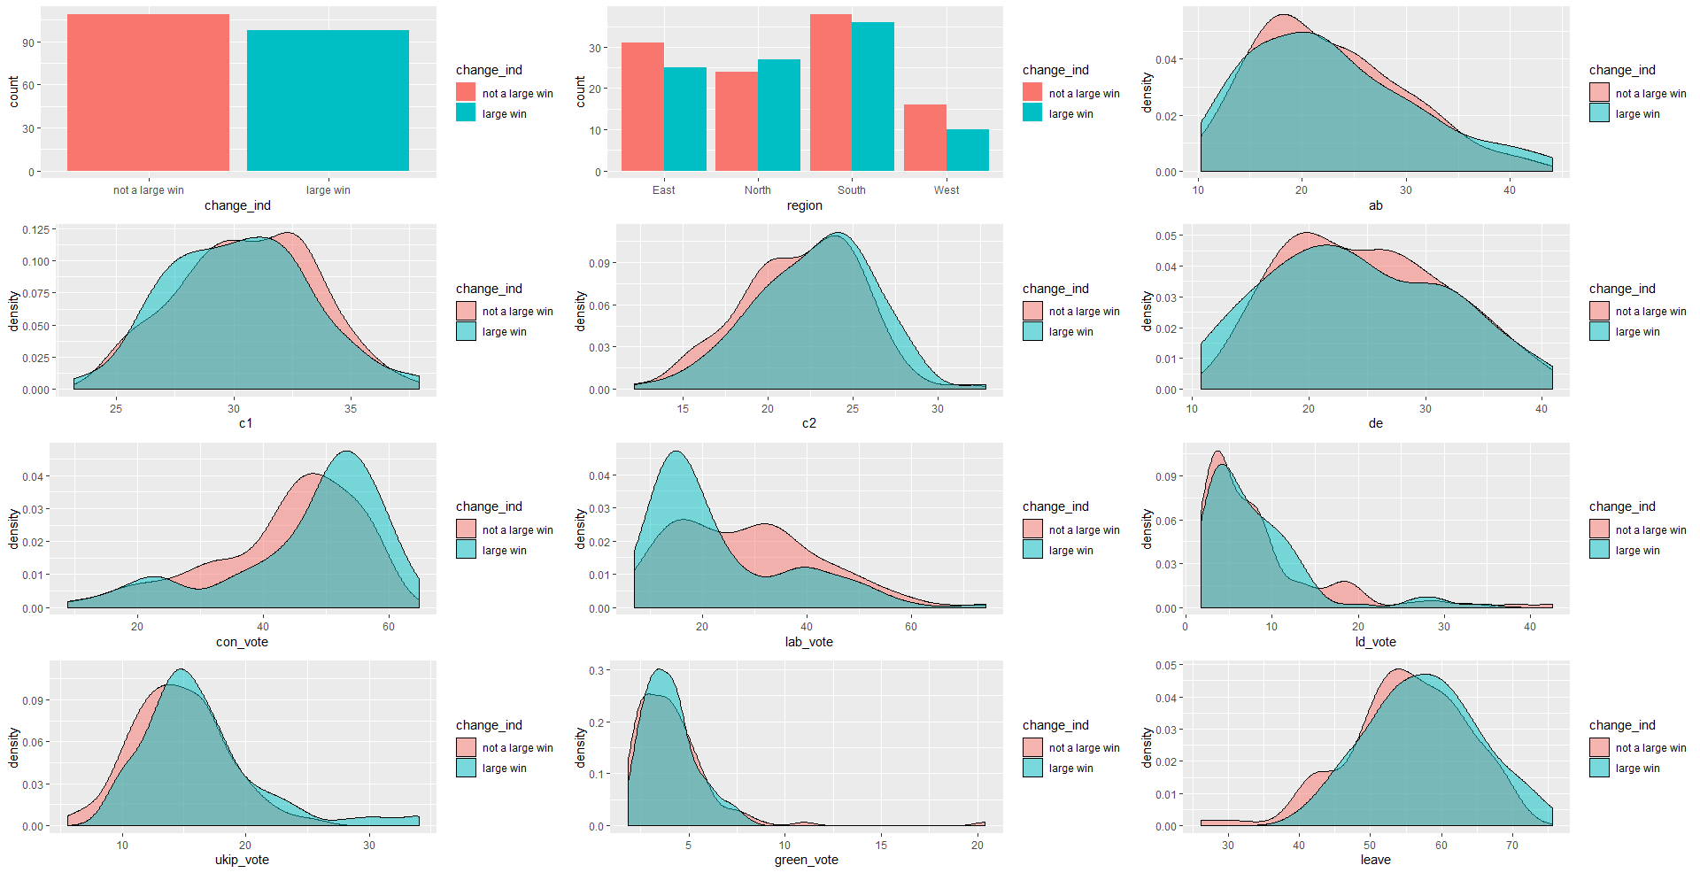

Figure 3.1‑8. Barplots and Density plots for the Independent dataframe

The results of the univariate analysis presented in Table 3.1.5. suggests that Social Grades AB, C1, DE, Liberal Democrat vote share 2017 and Green vote share 2017 are not of clinical importance in predicting whether or not the Independents will make a large proportion gain in a local authority. This is also evidenced in the density plots shown in Fig 3.1.8. (c,d,f,i,k) as there is overlap in the distribution of the two classes. The barplot on Fig 3.1.8 (b) does not indicate a clear pattern in the large gains made by the Independents among the four (4) regions.

Table 3.1‑6. A univariate analysis of the Greens “change” using a p-value threshold of 0.25 to select variables of clinical importance as recommended by (Scott et al., 2006).

|  |  |
| --- | --- |
| **Variable Name** | **P-Value** |
| Social Grade AB | <0.25 |
| Social Grade C1 | 0.637 |
| Social Grade C2 | 0.658 |
| Social Grade DE | <0.25 |
| Conservative Vote Share 2017 | <0.25 |
| Labour Vote Share 2017 | <0.25 |
| LibDem Vote Share 2017 | <0.25 |
| Green Vote Share 2017 | <0.25 |
| UKIP Vote Share 2017 | <0.25 |
| Leave EU Votes | <0.25 |

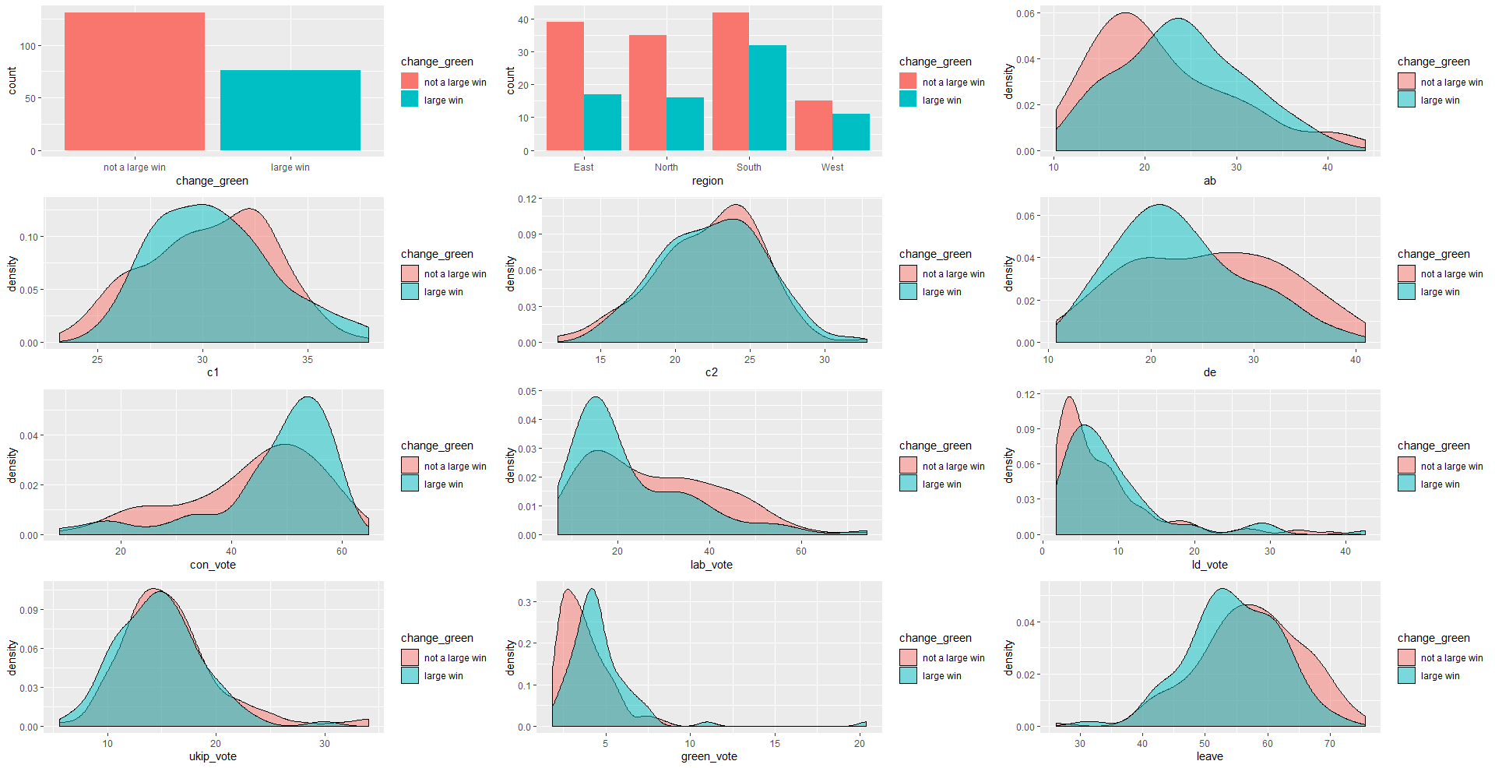

Figure 3.1‑9. Barplots and Density plots for the Green dataframe.

The results of the univariate analysis presented in Table 3.1.6. suggests that Social Grade C1 and C2 are not of clinical importance in predicting whether or not the Green party will gain a large proportion of seat in a local authority. The density plots shown in Fig 3.1.9 (d,e) evidences this as there is an overlap in the distribution of the two classes. It can also be observed that the density plots shown in Fig 3.1.9. (i,j) overlap significantly. We take this difference into account in obtaining our final model for the Green party. There is an inbalance in the two classes (large gain/not) as the Green party only fielded candidates in 30% of the total seats available in the election which gives them a zero change count in the LAs where they did not contest. This poses a limitation for our modelling approach. The barplot on Fig 3.1.9 (b) suggests that more of their large wins came from the south region.

## MODEL FITTING

### MODEL FOR CONSERVATIVE LOSS

The final model specified for the Conservative Party is:

where:

We report the model result as follows;

Table 3.2‑1. Result for Conservative Change Model

|  |  |  |  |  |
| --- | --- | --- | --- | --- |
| **Response:**  **Conservative change** | **Coeff (β)** | **Std. Error** | **Odds Ratio(**  **(95% CI)** | **P-Value** |
| Intercept | 3.85 | 3.3 | - | 0.25 |
| Social Grade AB | -0.18 | 0.07 | 0.83  (0.71, 0.95) | <0.05 |
| Conservative Vote Share 2017 | 0.22 | 0.04 | 1.24  (1.16, 1.36) | <0.05 |
| Liberal Democrat Vote Share 2017 | 0.08 | 0.03 | 1.09  (1.04, 1.16) | <0.05 |
| Leave EU Vote Share | -0.19 | 0.06 | 0.82  (0.73, 0.91) | <0.05 |

#### INTERPRETATION OF MODEL RESULT

------

### MODEL FOR LABOUR LOSS

The final model specified for the Labour party is:

where:

Table 3.2‑2. Result for Labour Change Model

|  |  |  |  |  |
| --- | --- | --- | --- | --- |
| **Response:**  **Labour change** | **Coeff (β)** | **Std. Error** | **Odds Ratio(**  **(95% CI)** | **P-Value** |
| Intercept(Region East) | -2.93 | 0.56 | - | <0.05 |
| Region North | 1.23 | 0.48 | 3.42  (1.33, 8.99) | <0.05 |
| Region South | -0.17 | 0.51 | 0.83  (0.30, 2.31) | 0.73 |
| Region West | 1.05 | 0.53 | 2.87  (1.01, 8.36) | <0.05 |
| Labour Vote Share 2017 | 0.06 | 0.01 | 1.06  (1.03, 1.09) | <0.05 |

#### INTERPRETATION OF MODEL RESULT

-----

### MODEL FOR LIBERAL DEMOCRAT GAIN

The final model specified for the Liberal Democrat party is:

where:

Table 3.2‑3. Result for Liberal Democrat Change Model

|  |  |  |  |  |
| --- | --- | --- | --- | --- |
| **Response:**  **Liberal Democrat change** | **Coeff (β)** | **Std. Error** | **Odds Ratio(**  **(95% CI)** | **P-Value** |
| Intercept | 3.27 | 1.63 | - | <0.05 |
| Conservative Vote Share 2017 | 0.05 | 0.01 | 1.05  (1.02, 1.08) | <0.05 |
| Liberal Democrat Vote Share 2017 | 0.08 | 0.02 | 1.08  (1.02, 1.15) | <0.05 |
| Leave EU Vote Share | -0.11 | 0.02 | 0.89  (0.84, 0.93) | <0.05 |

#### INTERPRETATION OF MODEL RESULT

------

### MODEL FOR INDEPENDENTS GAIN

The final model specified for the Independents is:

where:

Table 3.2‑4. Result for Independents Change Model

|  |  |  |  |  |
| --- | --- | --- | --- | --- |
| **Response:**  **Independents change** | **Coeff (β)** | **Std. Error** | **Odds Ratio(**  **(95% CI)** | **P-Value** |
| Intercept(Region East) | -0.66 | 0.74 | 0.51  (0.11, 2.18) | 0.37 |
| Region North | 1.31 | 0.49 | 3.71  (1.45, 10.15) | <0.05 |
| Region South | -0.03 | 0.39 | 0.96  (0.44, 2.12) | 0.93 |
| Region West | -0.03 | 0.51 | 0.96  (0.34, 2.63) | 0.95 |
| Labour Vote Share 2017 | -0.05 | 0.01 | 0.94  (0.91, 0.97) | <0.05 |
| UKIP Vote Share 2017 | 0.10 | 0.03 | 1.11  (1.03,1.20) | <0.05 |

#### INTERPRETATION OF MODEL RESULT

--------

### MODEL FOR GREEN GAIN

The final model specified for the Green party is:

where:

Table 3.2‑5. Result for Green Change Model

|  |  |  |  |  |
| --- | --- | --- | --- | --- |
| **Response:**  **Liberal Democrat change** | **Coeff (β)** | **Std. Error** | **Odds Ratio(**  **(95% CI)** | **P-Value** |
| Intercept | -3.15 | 0.74 | - | <0.05 |
| Conservative Vote Share 2017 | 0.02 | 0.01 | 1.02  (0.99, 1.05) | 0.05 |
| Liberal Democrat Vote Share 2017 | 0.34 | 0.11 | 1.41  (1.16, 1.75) | <0.05 |

#### INTERPRETATION OF MODEL RESULT

-----

## MODEL CHECKING

CHAPTER FOUR

# ADVANCED ANALYSIS

## EXPLORATORY DATA ANALYSIS

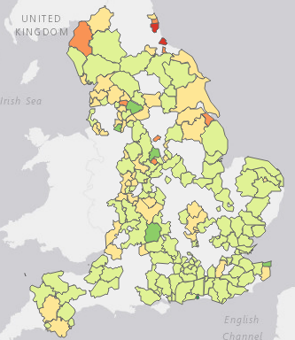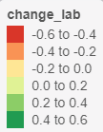

Figure 4.1‑2. Visualizing Labour Change

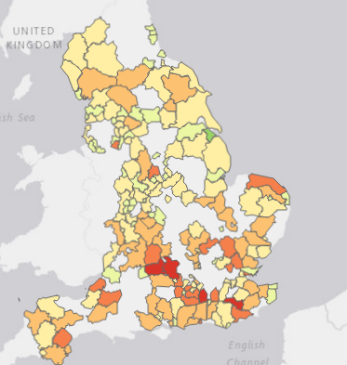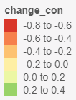

Figure 4.1‑1. Visualizing Conservative Change

The motivation for looking at the research problems from a spatial perspective arises from the fact that we have an areal unit data where the domain (England) is split into *n* non-overlapping units. Examining the plot on Fig 4.1.1, we can observe some clusters of areas where the Conservative party lost large proportion of seats. One might suggest a neighboring effect as a possible reason why this might be (a case where one areal unit influences another it shares a border with). Before we begin constructing spatial models for the dataset, it is sensible first check if the covariates in our earlier obtained models have not accounted for the spatial pattern in the responses. We do this by computing a Moran’s I test statistic for all the models obtained.

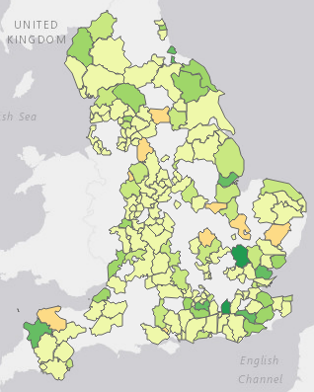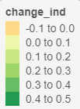

Figure 4.1‑4. Visualizing Independents Change

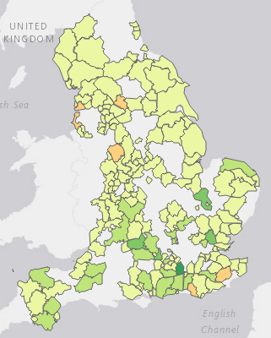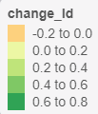

Figure 4.1‑1. Visualizing Liberal Democrat Change

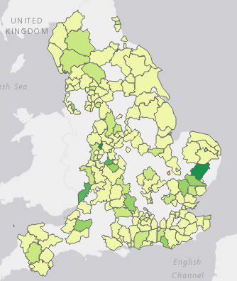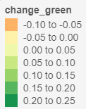

Figure 4.1‑2. Visualizing Green Change

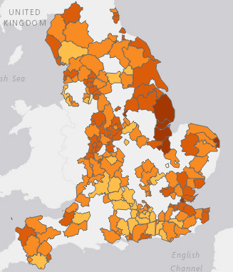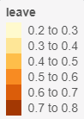

Figure 4.1‑3. Visualizing Leave EU Votes

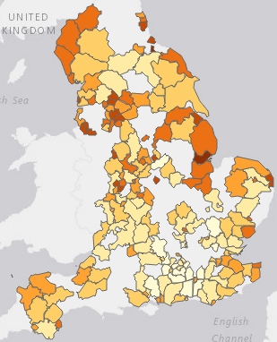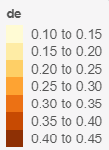

Figure 4.1‑4. Visualizing Social Grade DE Proportion

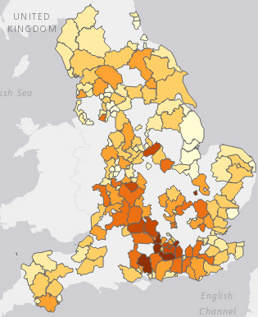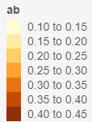

Figure 4.1‑5. Visualizing Social Grade AB Proportion

The motivation for looking at the research problems from a spatial perspective arises from the fact that we have an areal unit data where the domain (England) is split into *n* non-overlapping units.